July 1, 2021
SHUC Covid Safety Team: Communicable Disease Prevention

SHUC will be following the ‘ORDER OF THE PROVINCIAL HEALTH OFFICER
(Pursuant to Sections 30, 31, 32 and 39 (3) Public Health Act, S.B.C. 2008)
GATHERINGS AND EVENTS – June 30, 2021’

For SHUC renter groups please ensure the following:
- Do not exceed the maximum room capacity for meeting rooms posted on each door*
- Identify an “organizer”/ leader / ‘most responsible person’ on site for the event/meeting
- Participants once seated, must not move unless to assist someone else or go to the restroom
- Controlled entry / exit process
- Self serve food or drink station, participants must sanitize hands prior to use
- After event/meeting sanitize area, especially high touch surfaces
- Submit a ‘Safety Plan” to SHUC Safety Team
- Specific questions or need for clarification please contact Nina Matthews Office Administrator or delegate

Full excerpt from PHO June 30, 2021 order: C. INSIDE EVENTS
1. A person may permit a place to be used for, or may organize or be present at an inside
event, if the provisions of this Part are complied with.

2. No more than 50 persons, or 50% of the seated operating capacity of the place, excluding
event staff, whichever number is greater, are present.

3. There is an organizer.

4. Access to the event is controlled.

5. There is seating available for each participant, and each participant is assigned to a seat or
a table.

6. Participants are seated throughout the place in such a way as to use all available space.

7. Participants stay in the seat to which they are assigned, and do not move from seat to
seat.

8. Participants remain seated except
a. to use a self- serve food or drink station,
b. to use washroom facilities,
c. to provide assistance to another person who requires care or first aid, or
d. to leave or return to the place.

9. If there is a food or drink station,
a. hand washing facilities or alcohol-based sanitizers are within easy reach of the
station;

b. signs reminding participants to wash or sanitize their hands before touching self-
serve food, drink or other items, are posted at the self-serve station; and

c. high touch surfaces at the station, and utensils that are used for self- serve, are
frequently cleaned and sanitized.
10. Hand sanitation supplies are readily available to participants.
11. Toilet facilities with running water, soap and paper towels for hand washing and drying
purposes or hand sanitation supplies are available for participants.
12. There are a sufficient number of staff to ensure that
a. participants remain seated, and
b. participants do not congregate in parts of the place.
13. Dance floors are closed with physical barriers or occupied with tables, unless they are
being used for a dance performance.
14. Participants do not dance.
15. The organizer monitors the number of persons present and ensures that the number of
persons present does not exceed the maximum number permitted for an inside event.
16. A participant must not attend an inside event at which there are more persons present
than are permitted in this Part, and must not enter a place, or must leave a place, if so
directed by the organizer or a member of staff.
17. A participant must comply with the requirements in this Part, and with measures, or
guidance or directions from the organizer or a member of staff, intended to avoid the
congregation of participants.
18. If an event is held in part of a place which is completely separated from the rest of the
place, additional persons who are not attending the event may be present in other parts of
the place.
19. If there is more than one area in a place in which events may be held, there may be an
event in each of the areas.
20. If the organizer is not the owner of the place in which an inside event is held, the owner
must be satisfied that the organizer is aware of the conditions and requirements in this
Part and has the capacity to fulfill them.

Reference: GATHERINGS AND EVENTS – June 30, 2021
https://www2.gov.bc.ca/assets/gov/health/about-bc-s-health-care-system/office-of-the-provincial-health-officer/covid-19/covid-19-pho-order-gatherings-events.pdf

Worksafe BC - Communicable Disease Prevention Guide
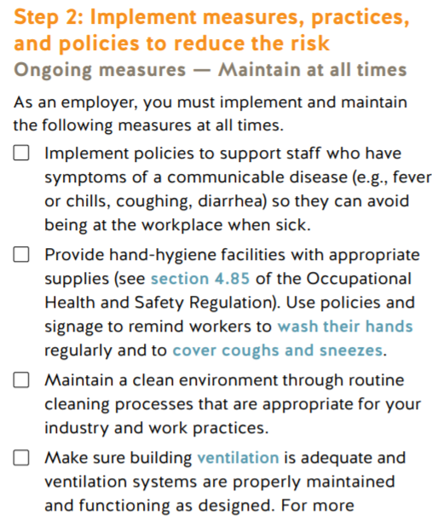
https://www.worksafebc.com/en/resources/health-safety/books-guides/communicable-disease-prevention-guide-employers?lang=en

BC is currently in Phase 3

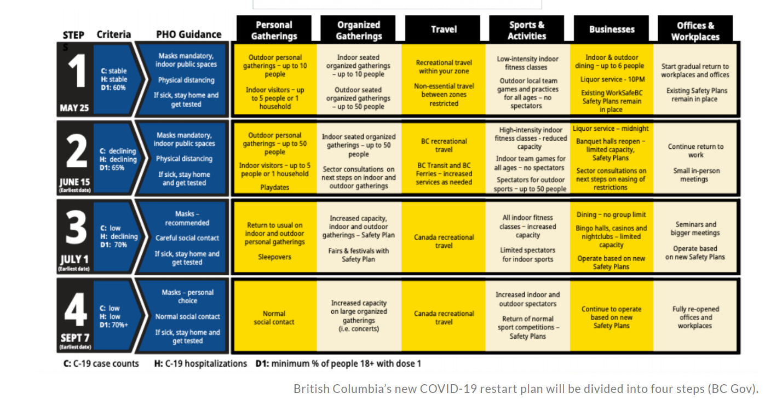

*From July 1 – Sept 6, 2021 the maximum capacity for each meeting space/room is posted outside each room, and is as follows: * seated, masked and 2 meter physically distanced.
Upstairs classroom - 12
Hall - 35
Gym – 35
Library - 4
Sanctuary 50 - 100
Chapel – 8-10
Lounge – 15
Narthex - 18

